DISASTER RECOVERY FAILOVER REPORT
Finacle Core Banking & Finacle Treasury – Tanzania
1. Document Control
Item | Details
Report Title | Finacle Core & Treasury DR Failover – Tanzania
Prepared By | Group IT Service Continuity Management
Systems in Scope | Finacle Core Banking, Finacle Treasury
Country | Tanzania
DR Type | Planned DR Failover Test
Environment | Production to DR
Status | Completed – Operating from DR
Report Classification | Confidential – Internal / Regulatory

2. Executive Summary (Management View)
A planned Disaster Recovery (DR) failover test for Finacle Core Banking and Finacle Treasury for Equity Bank Tanzania was successfully executed. The objective was to validate the bank’s ability to recover mission-critical systems within approved Recovery Time Objectives (RTOs), operate stably from DR for an extended period, and identify resilience gaps requiring remediation.
The failover was completed successfully, with both systems restored and operating from DR. Several operational, technical, and coordination issues were observed during execution, most of which were resolved within the test window. A small number of issues were identified as external third-party dependencies and were confirmed not to be caused by the failover.
Overall, the test demonstrated recoverability, but also highlighted process, coordination, and configuration weaknesses that must be addressed to improve resilience and reduce recovery risk during a real disaster.
3. Objectives of the DR Test
The objectives of this DR exercise were to:
- Validate the ability to fail over Finacle Core and Treasury from Production to DR.
- Confirm recovery within approved RTOs.
- Validate application, integration, and channel functionality from DR.
- Identify gaps in people, process, technology, and third-party dependencies.
- Build confidence for extended DR operations (≥ 30 days).
- Generate audit-ready evidence for regulatory and Board assurance.
4. Scope of the Failover
In Scope
- Finacle Core Banking (TZ)
- Finacle Treasury (TZ)
- Supporting middleware and integrations
- Digital and branch-dependent channels
- Core interfaces (Way4, Omni, Newgen, USSD, Agency, etc.)
Out of Scope
- Non-production systems
- Business continuity processes outside IT
- External third-party service restoration (where providers were unavailable)
5. Governance, Policy & Best-Practice Alignment
This exercise aligns with:
- Equity Group IT Disaster Recovery & Backup Policy
- ISO 22301 – Business Continuity Management
- ITIL / COBIT – IT Service Continuity
- Regulatory expectations (BOT)
Change approvals, execution oversight, evidence capture, and post-test review were conducted in line with policy requirements.
6. Pre-Failover Readiness Assessment
Strengths
- Approved DR runbooks were available.
- DR infrastructure was in a recoverable state.
- Key technical teams were mobilized.
- Prior lessons learned were referenced during execution.
- Still operating from the DR environment
- 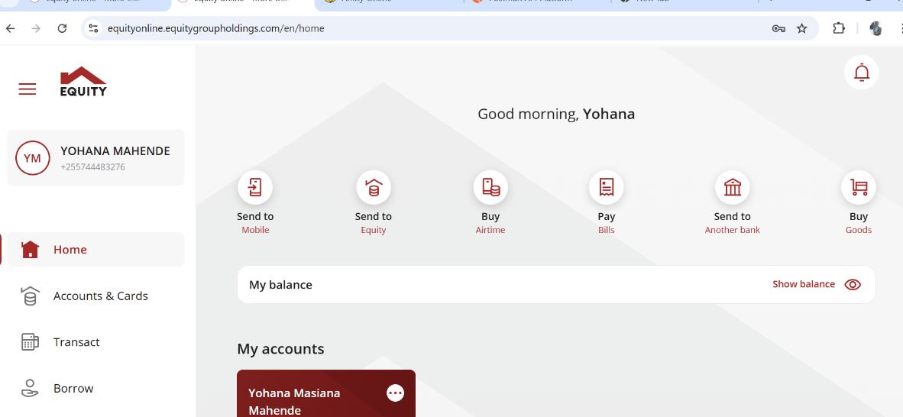

Gaps Identified
- Some critical roles (DBA, DevOps, NOC) were not present at the start.
- Incomplete pre-call attendance confirmation.
- DR monitoring visibility gaps for TZ environment.
- Dependency on manual coordination rather than automated orchestration.
7. Failover Execution Summary
Execution Approach
- Sequential failover: Finacle Core first, followed by Finacle Treasury
- Controlled shutdown of Production services
- Database switch and application re-pointing to DR
- Service restart and validation
- Functional testing by business and IT teams
Key Timings (High Level)
- Failover initiated and completed within the following test thresholds.
- Some delays were experienced due to troubleshooting and coordination issues.
- Final stabilization achieved and systems confirmed operational from DR.
8. Issues Identified During Failover
8.1 People & Coordination Issues
- Delay in availability of DBA, DevOps, and NOC resources.
- Roll-call and confirmation extended the start window.
- Manual follow-ups required to bring critical resources into the call.
Risk: In a real disaster, delayed availability could materially extend downtime.
8.2 Technical & Configuration Issues
- Treasury users unable to log in due to incorrect IP configuration after failover.
- Initial failures in Way4 transactions (RC 907 / 904).
- CoreServer responsiveness issues for some users.
- Omni account inquiry failures until Finacle services stabilized.
- Some services required manual restart and re-pointing.
Risk: High dependency on manual configuration increases recovery time and error risk.
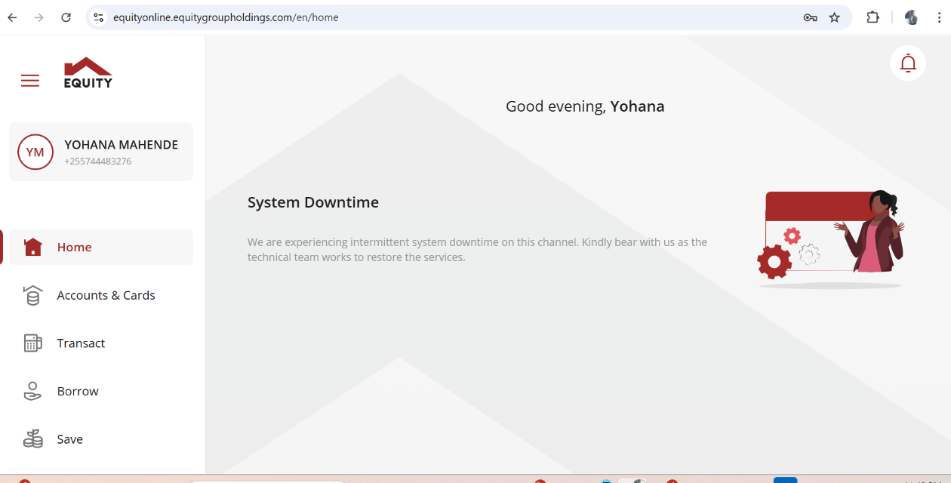
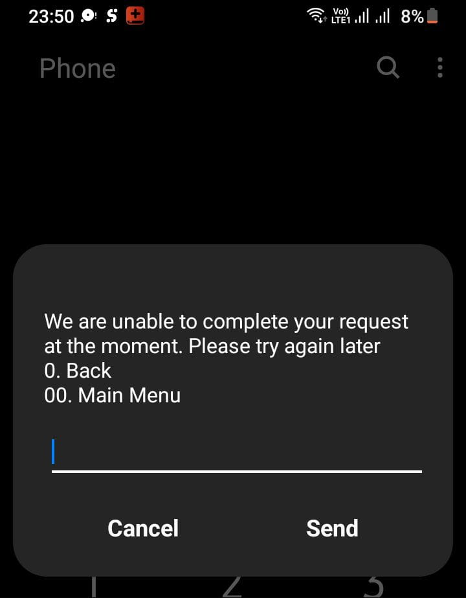

8.3 External Dependency Failures (Not Caused by DR)
- Credit Bureau (DNB) services were unavailable due to third-party outage.
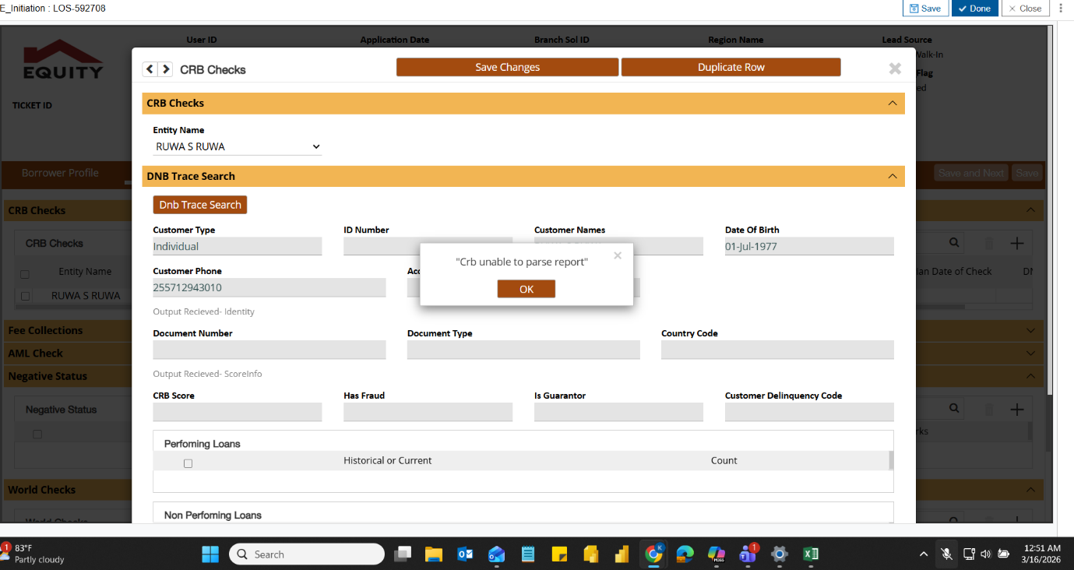

- Some TIPS rail transaction delays observed.
These were confirmed as external failures and not DR-induced.
Risk: External dependencies materially affect customer experience even when core systems are healthy.
8.4 Functional Testing Gaps
- Intermittent issues on:
  - Loans (Johari / Newgen)
  - Omni channels
  - USSD loan menus
  - Treasury rate request workflows
- Some tests required retries after stabilization.
Risk: Insufficient automated validation increases time to business confidence.
8.5 Monitoring & Observability Gaps
- DR environment monitoring for TZ was not fully visible in NOC dashboards.
- Limited real-time assurance during failover.
Risk: Reduced situational awareness during incidents.
9. What Worked Well
- Core systems were successfully recovered.
- Teams collaborated effectively under pressure.
- Known historical issues (e.g., DB connection testing) were proactively discussed.
- Functional testers actively validated services.
- Decision-making remained centralized and controlled.
10. Key Lessons Learned
- Attendance discipline is critical – all runbook owners must be present before execution.
- Manual failover steps remain a risk – automation is required.
- Third-party dependencies must be explicitly tracked in DR scenarios.
- Monitoring must cover DR environments equally.
- Functional testing should be standardized and faster.
- Extended DR operation readiness must be tested deliberately, not assumed.
11. Risk Assessment (Post-Failover)
Risk Area | Rating | Commentary
Recoverability | Medium | Systems recovered, but with avoidable delays
Process Maturity | Medium | Manual steps and coordination gaps
Third-Party Dependency | High | External outages impact service
Automation | High | Failover heavily manual
Monitoring | Medium | DR visibility gaps
Audit / Regulatory Risk | Medium | Evidence exists, improvements required
12. Management Recommendations
- Mandate pre-failover attendance sign-off for all runbook owners.
- Automate failover orchestration where feasible (DB, middleware, integrations).
- Enhance DR monitoring visibility in NOC tools.
- Formalize third-party DR dependency mapping and escalation paths.
- Standardize functional test scripts with clear pass/fail criteria.
- Run periodic extended DR operations to validate endurance.
13. Action Plan
Action | Owner | Priority
Update runbooks with mandatory attendance controls | ITSCM | High
Implement DR automation roadmap | Infrastructure / Apps | High
Enable TZ DR monitoring in NOC tools | NOC | High
Document third-party DR dependencies | ITSCM / Vendors | Medium
Improve functional test scripts | Business / IT | Medium
Schedule post-implementation review (PIR) | ITSCM | High
14. Conclusion
The Finacle Core and Treasury DR failover test successfully demonstrated recoverability and the bank’s ability to operate from DR. However, the exercise exposed material improvement areas in coordination, automation, monitoring, and dependency management. Addressing these gaps will materially reduce operational risk, improve regulatory confidence, and strengthen the bank’s resilience posture.

15. Appendix: Operating from the DR Environment
